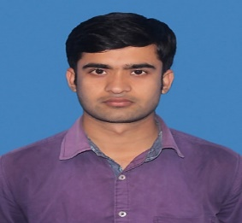

**ANSHU KUMAR SINGH**

Course : MCA,COMPUTER APPLICATION

[Email : anshukumarsingh444@gmail.com](mailto:anshukumarsingh444@gmail.com) Mobile : 7870372238

CGPA : 7.24

|  |  |  |  |  |  |
| --- | --- | --- | --- | --- | --- |
| **ACADEMIC DETAILS** | | | | | |
| COURSE | SPECIALIZATION | INSTITUTE/COLLEGE | BOARD/UNIVERSITY | % CGPA | YEAR |
| X | General | CAMBRIAN PUBLIC SCHOOL | CBSE | 6.2 CGPA | 2011 |
| B Sc | Computer Science | DORANDA COLLEGE RANCHI | RANCHI UNIVERSITY RANCHI | 74.58 % | 2018 |
| XII | Science | S.S.COLLEGE MEHUS SHEIKHPURA BIHAR | BIHAR SCHOOL EXAMINATION BOARD PATNA | 64.8% | 2015 |
| MCA | Computer Application | BIRLA INSTITUE OF TECHNOLOGY |  | 7.24 CGPA | 2021 |

**BIT MESRA**

* I am holding the post of Sports Secretary July 2019-2021 of our hostel in BIT MESRA.

**POSITION OF RESPONSIBILITY**

JAVA, DBMS, SQL, WEB DEVELOPMENT, one month of **machine learning** internship using python, 8 moths full stack developer course on NEWTON SCHOOL(appearing)

**Electives**

**Technical Proficiency**

**TECHNICAL PROFICIENCY**

**EXTRA CURRICULAR ACTIVITIES**

I am holding the post of Sport Secretary July 2019-2021 of our Hostel in BIT MESRA. I am a winner of the school league cricket tournament.

I am a district level kabaddi player of Ranchi. I won the Ranchi University championship kabaddi tournament in 2017.